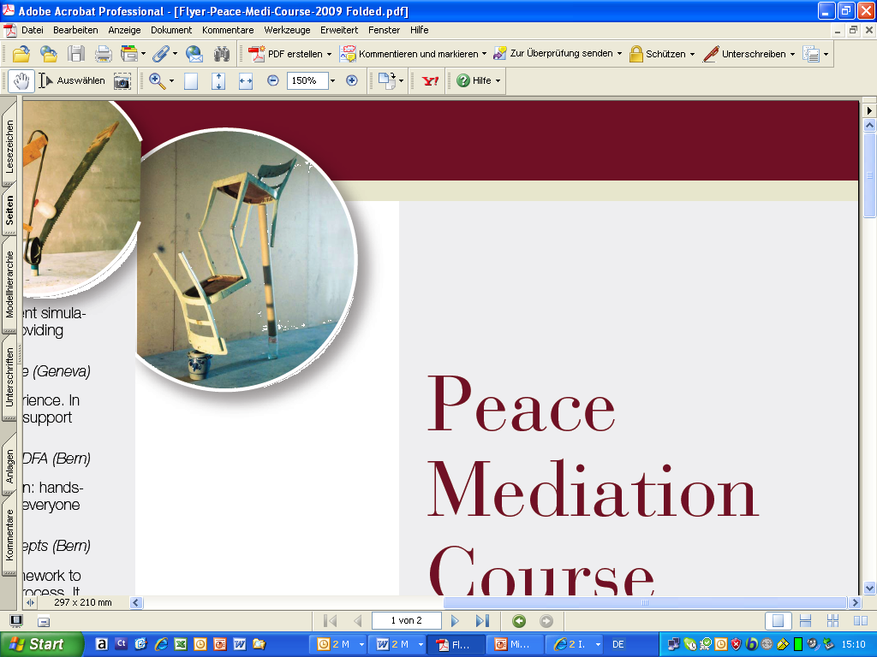
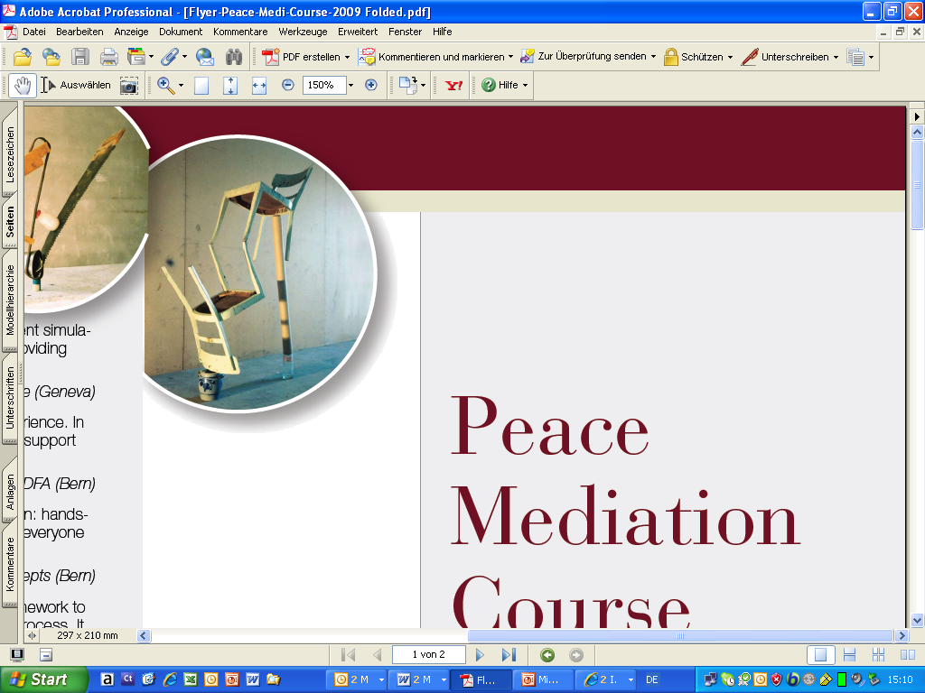

22

DRAFT Program Overview - Peace Mediation Course 2019

Time | Topic | Trainer | Block
Sun, 30 June  Start at 16:00 | Introduction to the course and joint dinner | Matthias Siegfried / Philipp Lustenberger
Mon, 1 July | Overview of mediation today / Mediation analysis / Introduction to negotiation | Julian Thomas Hottinger / Philipp Lustenberger / Katrina Abatis | Context /  Negotiation
Tue, 2 July | Negotiation skills  Evening: social event | Simon Mason / Philipp Lustenberger / MSP | Context /  Negotiation
Wed, 3 July | Mediation skills | Bill Marsh / Simon Mason | Mediation
Thu, 4 July  Morning | Mediation skills | Bill Marsh | Mediation
Afternoon | Process Design and Multi-track mediation | Simon Mason / Philipp Lustenberger and Meredith Preston McGhie | Process  Design
Fri, 5 July | Cases of multi-track mediation | Meredith Preston McGhie | Process  Design
Sat, 6 July  Until 15:00 | Processes & modalities of inclusion | Thania Paffenholz | Process  Design
Sun, 7 July | Free Day
Mon, 8 July | Mediating security arrangements in peace processes | Georg Stein | Process design
Tue, 9 July | Power sharing arrangements in peace processes  Evening: fire side chat | Marie-Joelle Zahar | Process design
Wed, 10 July | Track 1-1.5, formal processes, high powered mediation | Julian Thomas Hottinger | Process design
Thu, 11 July | Role play  Evening: social event | Julian Thomas Hottinger,  (Simon Mason / Philipp Lustenberger) | Exercise
Fri, 12 July  Morning | Debriefing of role play /  Open questions | Julian Thomas Hottinger | Exercise
Afternoon  End at 16:00 | Mediation and Swiss foreign policy /  Wrap-up, handing out of certificates | Stéphane Rey / Georg Stein

