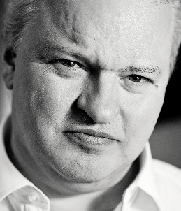
Bill Marsh
Outline Profile

Formerly a corporate lawyer, Bill has mediated full-time since 1991 in a wide range of disputes and conflicts involving governments, businesses, factions, pressure groups and individuals from over 50 countries, and covering commercial, religious, ethnic and political conflicts.

He has served as adviser on mediation/conflict resolution to many governments (eg Russia, Ukraine, Turkey, Romania, Bulgaria, Slovakia) and public institutions (eg UN, EU Commission, IFC/World Bank), and trains and mentors mediators from around the world. He serves as Special Adviser on Reconciliation to the Archbishop of Canterbury, and last year received the Archbishop’s inaugural award for outstanding services to reconciliation. He is on the Advisory Board of the All Party Parliamentary Group on Conflict Issues in the UK Parliament.

He has been independently ranked every year as one of the UK’s top commercial mediators, and was ranked “Global Mediator of the Year 2014-15” by Who’s Who Legal.

